E-commerce Data Dictionary
Purpose for Sprint 1:
This document provides an overview of the main tables and fields in the e-commerce dataset. It defines key attributes, data types, and relationships to support accurate data analysis. Null values should be interpreted based on their business meaning rather than automatically replaced with zero.

Data Model & Table Relationships:
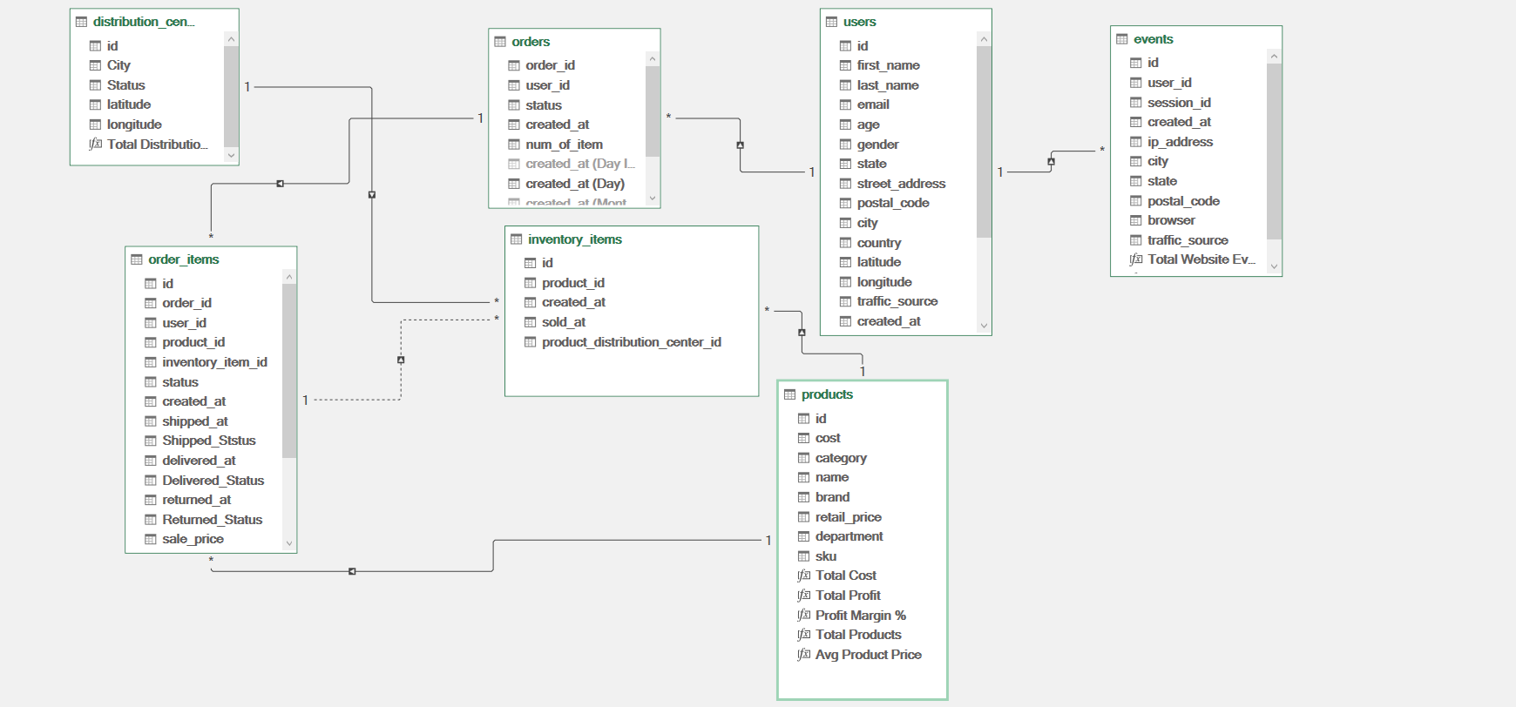
The data model illustrates the relationships between the seven main tables in the e-commerce dataset: users, orders, order_items, products, inventory_items, distribution_centers, and events.
It highlights the key fields used to connect these tables, enabling integrated analysis of customer behavior, order performance, product sales, inventory, and website activity. Understanding these relationships helps ensure data consistency and supports accurate reporting and business insights.
The model serves as a reference for data preparation, relationship validation, and dashboard development in Power BI.

1. Distribution Centers
Table Type: Dimension Table
Table Description:
Stores information about the distribution centers responsible for storing and distributing products.
Column Definitions:
- id: Unique identifier for each distribution center. Primary Key (PK).
- name: Name of the distribution center.
- latitude: Geographic latitude of the distribution center.
- longitude: Geographic longitude of the distribution center.

2. Events
Table Type: Fact Table / Event Log
Table Description:
Records website activity and customer interactions. This table supports website funnel analysis by tracking events such as home page visits, department browsing, product views, cart activity, and purchases.
Column Definitions:
- id: Unique identifier for each recorded event. Primary Key (PK).
- user_id: Identifier of the user associated with the event. May be NULL for guest visitors.
- sequence_number: Sequence number used to represent event order within the tracking data.
- session_id: Identifier of the browsing session.
- created_at: Date and time when the event occurred.
- ip_address: Technical field containing the visitor's IP address. Usually unnecessary for standard business reporting.
- city: City associated with the recorded event.
- state: State associated with the recorded event.
- postal_code: Postal code associated with the recorded event.
- browser: Browser used during the browsing session.
- traffic_source: Traffic source recorded for the event or session. It may differ from the user's original acquisition source.
- uri: Page URL or URI visited by the user.
- event_type: Type of website activity, such as home, department, product, cart, purchase, or cancel.
Derived Field — Event Dates:
If created in Power Query, this field should be documented as a derived column rather than an original source field. Its definition and data type should reflect the actual transformation performed.
Analytical Notes:
- Event data can be used to analyze customer navigation and conversion funnels.
- Missing user IDs should not automatically be treated as invalid records, since they may represent guest activity.
- Event sequences and timestamps should be validated before session-level analysis.

3. Inventory Items
Table Type: Inventory Fact Table / Stock-Unit Level
Table Description:
Contains records for individual inventory units, including their associated products, costs, and relevant inventory dates.
Column Definitions:
- id: Unique identifier for each inventory unit. Primary Key (PK).
- product_id: Identifier of the product associated with the inventory unit. Foreign Key (FK) referencing products.id.
- created_at: Date and time when the inventory record was created.
- sold_at: Date and time when the inventory unit was sold. NULL may indicate that no sale date is recorded.
- cost: Cost associated with the inventory unit.
- product_category: Product category, if included in the source or added during data preparation.
- product_name: Name of the associated product, if available.
- product_brand: Brand of the associated product, if available.
- retail_price: Listed retail price of the associated product.
- department: Department to which the associated product belongs.
- sku: Stock Keeping Unit used to identify the product.
- product_distribution_center_id: Identifier of the distribution center associated with the inventory record.
Analytical Notes:
- Product attributes repeated in this table should be checked against the products table.
- The cost field should be used at the inventory-unit level when analyzing the cost of a specific sold unit.
- NULL values in sold_at should be interpreted according to the business context and validated against the inventory status.

4. Order Items
Table Type: Fact Table / Order-Line Level
Table Description:
Contains item-level records associated with customer orders. It supports detailed sales, fulfillment, and return analysis.
Column Definitions:
- id: Unique identifier for each order-item record. Primary Key (PK).
- order_id: Identifier of the order containing the item. Foreign Key (FK) referencing orders.order_id.
- user_id: Identifier of the customer associated with the order item. This field may duplicate information available through the related order.
- product_id: Identifier of the purchased product. Foreign Key (FK) referencing products.id.
- inventory_item_id: Identifier of the inventory unit associated with the order item. Foreign Key (FK) referencing inventory_items.id, where applicable.
- status: Current or recorded status of the order item, useful for fulfillment and return analysis.
- created_at: Date and time when the order-item record was created.
- shipped_at: Date and time when the item was shipped. NULL may indicate that no shipment date is recorded.
- delivered_at: Date and time when the item was delivered. NULL may indicate that no delivery date is recorded.
- returned_at: Date and time when the item was returned, if applicable.
- sale_price: Actual recorded sale price of the order item.
Analytical Notes:
- Use sale_price for revenue calculations at the order-item level.
- Order-item status should be used when analyzing individual item returns, rather than relying exclusively on order-level status.
- Confirm the grain of the table before calculating unit-based return rates or quantities.

5. Orders
Table Type: Fact Table / Order Level
Table Description:
Stores order-level information, including customer references, order status, timestamps, and the number of items associated with each order.
Column Definitions:
- order_id: Unique identifier for each order. Primary Key (PK).
- user_id: Identifier of the customer who placed the order. Foreign Key (FK) referencing users.id.
- status: Recorded order status, such as Complete, Shipped, Processing, Cancelled, or Returned, depending on the values present in the dataset.
- gender: Gender value recorded for the order, if available. Compare with users.gender when consistent customer-level analysis is required.
- created_at: Date and time when the order was created.
- returned_at: Date and time associated with the order return, if recorded.
- shipped_at: Date and time when the order was shipped.
- delivered_at: Date and time when the order was delivered.
- num_of_item: Number of items associated with the order.
Analytical Notes:
- Order-level and item-level statuses may differ.
- Use the appropriate table grain when calculating order return rates versus item return rates.
- NULL timestamps should be interpreted according to the order's lifecycle and recorded status.

6. Products
Table Type: Dimension Table
Table Description:
Contains product attributes used to classify products and support sales, pricing, and product-performance analysis
Column Definitions:
- id: Unique identifier for each product. Primary Key (PK).
- name: Product name.
- brand: Brand associated with the product.
- category: Product category.
- department: Department to which the product belongs.
- cost: Recorded product cost.
- retail_price: Listed retail price of the product.
- sku: Stock Keeping Unit used to identify the product.
- distribution_center_id: Identifier of the associated distribution center. Foreign Key (FK) referencing distribution_centers.id.
Analytical Notes:
- Use order_items.sale_price for recorded sales revenue rather than assuming that retail_price represents the actual transaction price.
- The difference between retail_price and cost represents an estimated product-level margin, not necessarily actual profit.
- Validate product costs and prices before using them in financial calculations.

7. Users
Table Type: Dimension Table
Table Description:
Contains customer information used to analyze demographics, customer acquisition, geographic distribution, and relationships between customers, orders, and website events.
Column Definitions:
- id: Unique identifier for each user. Primary Key (PK).
- first_name: Customer's first name.
- last_name: Customer's last name.
- email: Customer's email address.
- age: Customer's recorded age.
- gender: Customer's recorded gender.
- state: State associated with the customer's address.
- city: City associated with the customer's address.
- country: Country associated with the customer's address.
- street_address: Customer's recorded street address.
- postal_code: Postal code associated with the customer's address.
- latitude: Geographic latitude associated with the customer's location.
- longitude: Geographic longitude associated with the customer's location.
- traffic_source: Recorded source through which the user originally arrived at the website.
- created_at: Date and time when the user account was created.
Analytical Notes:
- Customer attributes can support demographic and geographic analysis.
- The traffic_source field represents the recorded user acquisition source and may differ from the source associated with a later browsing session.
- Personal identifiers, such as names, email addresses, and street addresses, should be excluded from reports unless they are specifically required for the analysis.

Relationships
The data model consists of seven source tables: distribution_centers, events, inventory_items, order_items, orders, products, and users.
The following relationships connect the main tables in the model:
- users.id → orders.user_id: Links each order to the customer who placed it.
- users.id → events.user_id: Connects website events to the associated customer.
- orders.order_id → order_items.order_id: Links orders to their individual items.
- products.id → order_items.product_id: Connects products to the corresponding order items.
- products.id → inventory_items.product_id: Links products to their inventory records.
- distribution_centers.id → products.distribution_center_id: Identifies the distribution center associated with each product.
- inventory_items.id → order_items.inventory_item_id: Connects an order item to its corresponding inventory record. This relationship is inactive in the current model and may be used in specific calculations when required.
Note: Relationship cardinality, active status, and filter direction should be validated in Power BI. A separate Calendar table may be created for time-based analysis, but it is not one of the seven original source tables.

Data Model (Snowflake Schema)
Model Structure
The data model follows a dimensional modeling approach with a snowflake-style structure.
Fact Tables
- order_items: Stores order-line data used for sales, fulfillment, and item-level return analysis.
- events: Records website activity and customer interactions for behavioral and conversion funnel analysis.
- inventory_items: Contains inventory-unit records, including product references, costs, and inventory dates.
Dimension Tables
- users: Contains customer attributes used for demographic, geographic, and customer-level analysis.
- products: Stores product details, including names, brands, categories, departments, and prices.
- orders: Contains order-header information, including order status, customer references, and order dates.
- calendar: A date dimension used for time-based analysis, if created in Power BI.
Snowflake Structure
The distribution_centers table is linked to products through distribution_center_id. The products table is then linked to relevant transactional and inventory tables through product identifiers. This dimension-to-dimension relationship introduces a snowflake-style structure.
Relationship Configuration
- Cardinality: One-to-Many (1:*) where supported by the actual data and model design.
- Cross-filter direction: Single direction, where configured in Power BI.
- Calculated Columns: No additional calculated columns were created in Power Query.
- Measures: Business calculations are implemented using DAX measures.
Modeling Notes
The calendar table is a supporting date dimension and is not one of the seven original source tables. It should be documented as a model-generated table only if it has actually been created.
Relationship cardinality, filter direction, and active status should be validated against the implemented Power BI model.
Business Rules
The following business rules define how sales, returns, and missing values are handled throughout the analysis.
1. Sales and Cancellation Rules
- Cancelled Items: Items with a Cancelled status are excluded from sales calculations.
- Eligible Sales: Items with Processing, Shipped, or Complete statuses are included in sales calculations, according to the defined reporting logic.
- Returned Items: Returned items are included in Gross Sales figures and deducted when calculating Net Sales.
2. Missing Value Handling
- Missing Text Values: Missing descriptive text values in dimension tables are replaced with "Unknown" where appropriate.
- Missing Numeric Values: Missing numeric values remain NULL or blank and are not automatically replaced with zero.
- Missing Dates: Missing date values remain blank when they indicate that an event has not occurred or no date has been recorded.
- Missing Keys: Missing key values remain blank and are investigated when necessary to determine whether records can be linked reliably.
3. Calculation Consistency
- Sales and return calculations are performed at the appropriate data granularity to avoid double counting.
- Order-level statuses and order-item-level statuses are evaluated separately.
- Gross Sales and Net Sales follow consistent definitions across all reports and dashboards.

